**Email Bounce Rate Analysis – Product Support Specialist Assignment**

**Name:** Prakrati Gupta

**Date:** 20/04/2025

**Objective:**

This report investigates the spike in email bounce rates in May, identify the root cause, and suggest solutions using SMTP response data.

**Data Overview:**

Dataset of SMTP responses per email domain of end customers for the last 6 months.

The first column represents the UNIX timestamp, and the rest contain information about SMTP response and end customer’s email domain.

**Hypothesis:**

The bounce rate increased in May due to stricter spam filtering or domain reputation issues, particularly from domains like centrum.sk and gmail.com, which showed a noticeable increase in bounce activity.

**Investigation Steps:**

To identify the root cause of the increased email bounce rate in May, the following structured approach was followed:

1. **Timestamp Conversion & Month Grouping**

The raw data contained UNIX timestamps. These were converted into readable date formats using Excel formulas.

A new column was added to group emails by month (formatted as mmmm) for time-based analysis.

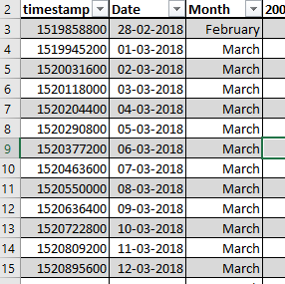

**Image 1. Add new month column**

1. **SMTP code Categorization**

SMTP response codes were grouped into categories to better understand bounce behaviour:

* 200 – Success
* 421 /550 / 552 / 554 – Bounces (failures)

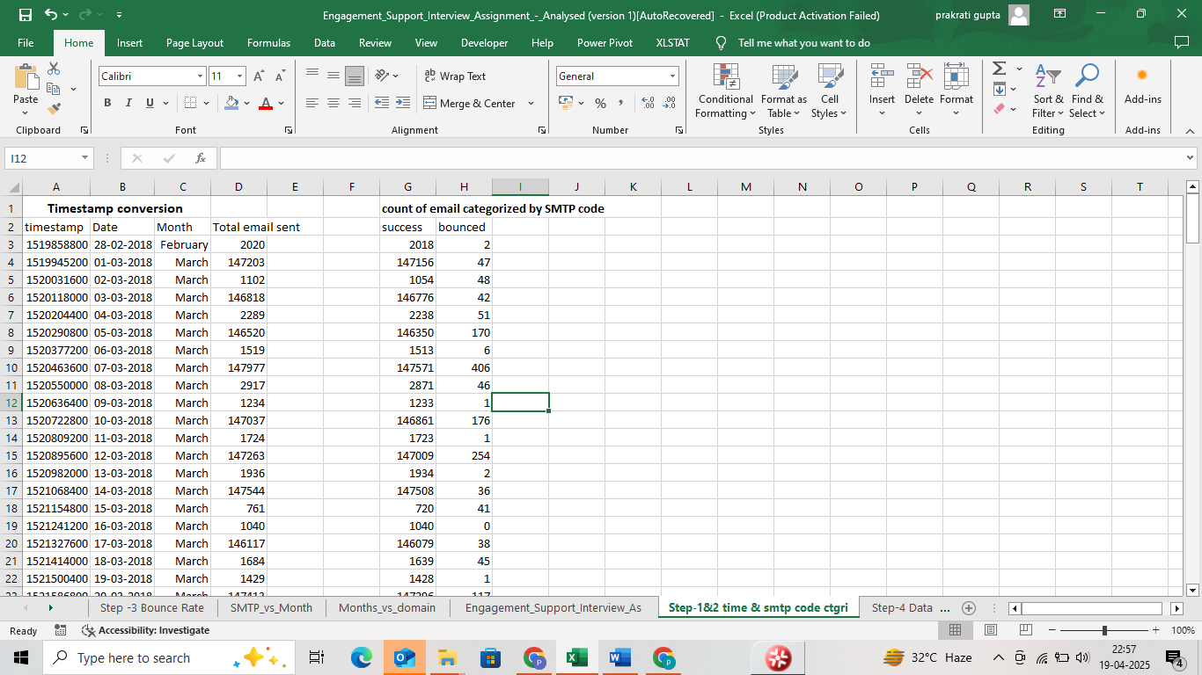

**Image 2. Grouped SMTP response columns**

1. **Bounce Rate Calculation by Month:**

* Used PivotTables to compute monthly bounce rates (bounced / total emails sent).

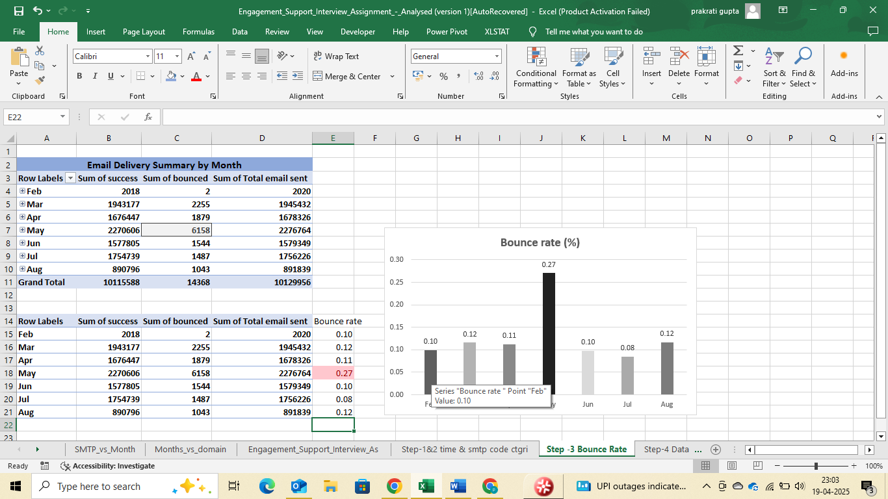

**Image 3. Monthly Trend Summary**

1. **Data Transformation with Power Query**

Used Power Query Editor to unpivot the wide dataset (columns for each SMTP code + Domain) into a tidy format with columns for Month, SMTP Code, Domain, and Count.

Split the combined SMTP code, Domain values into separate fields for easier analysis.

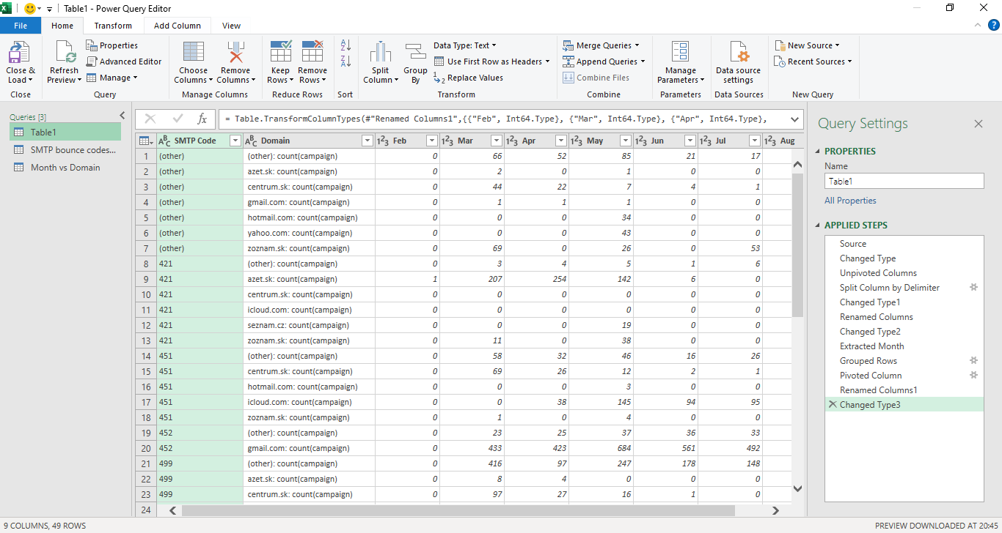

**Image 4. Data Transformation with Power Query**

1. **Pivot Table Creation for Summary Views**

Built PivotTables to explore:

* Monthly trends of total bounces by SMTP Code
* Bounce counts across different email domains
* Domain-wise distribution of bounce codes.

1. **Interactive Slicers and Charts**

Added slicers to dynamically filter data by:

* Month
* SMTP Code
* Domain

Used charts (column and line) to visualize spikes and compare domain or error code trends month-over-month.

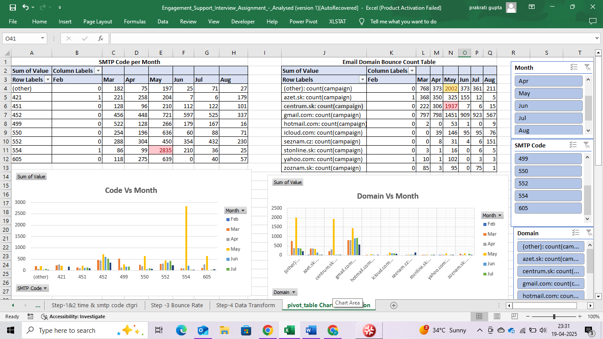

**Image 5. Interactive Slicers and Pivot Chart Visualization**

1. **Pattern Detection for May:**

By using slicers and charts, May was isolated as a high-bounce month.

Filtering revealed that a sharp spike in 554 errors was primarily linked to the domain centrum.sk, suggesting invalid or outdated email addresses in that domain during May.

**Key Findings:**

* **Monthly Trend Summary**

Quantitative analysis across months revealed that May had a significantly elevated bounce rate of **0.27%,** more than double the bounce rates observed in April (0.11%) or March (0.12%).

**Image 6. Monthly Bounce Rate (%)**

* **SMTP Code Trends**

**554** was the most frequent bounce code across all domains.

It indicates permanent issues like blocked content, domain blacklisting, or spam-like behaviour.

**Image 7. SMTP Code by Domain Chart**

* **Domain-Specific Analysis**
* In May, bounce rates spiked significantly.
* Centrum.sk alone contributed to **31%** of all bounces.
* Gmail.com followed at **24%.**

**Image 8. Domain Bounce Distribution Chart**

* **Centrum.sk Focus:**

The domain **centrum.sk** was responsible for the majority of these **554 errors**, with:

* **1884** bounces in May (vs. only 53 in April).

No similar spike was observed in other months or from other domains. Indicates potential domain-specific blocking or deliverability issues.

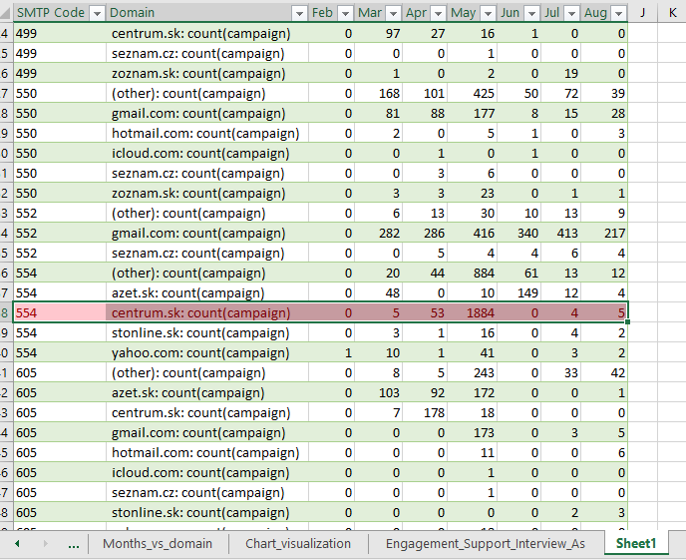

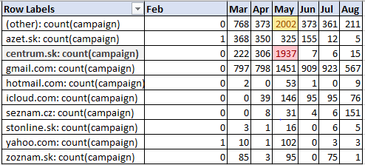

**Image 9&10.** **Centrum.sk Bounce Trend**

**Conclusion:**

After analysing the SMTP response data over the past six months, the increased bounce rate in May was primarily due to a large number of hard bounces **(554)** from the domain **centrum.sk**. This suggests that emails may have been sent to invalid or outdated addresses within this domain, possibly due to a recent import of contacts or a stale mailing list.

**Proposed Solution & Next Steps:**

To mitigate the issue and prevent future bounce spikes, the following actions are recommended:

* **Clean the contact list** for centrum.sk:

Remove or suppress addresses that previously resulted in 554 errors.

* **Suppress known hard bounce domains** from future campaigns.
* **Contact the client** to confirm if there was any recent contact import, CRM sync, or change in targeting strategy.
* Ensure **proper email warmup** when using new sender domains or increasing volume. Gradual ramp-up helps establish trust and reduces bounce rates.